0549 Shelter Kit (Yurt) & 0581 Insulation Kit
- Nomenclature in ICBS and IROC
  - NFES 000549 (KIT – SHELTER, 20’ OCTAGON)
  - NFES 000581 (KIT – INSULATION, SHELTER, 20’ OCTAGON)

- The new national shelter kit (0549) is expected to fully replace the aging Weatherports (8706) by the start of the 2022 season.

- Average first time set-up is 30 minutes with 4 crew members. Experienced crews can set up in about 15 minutes.

- Current cache stocking levels:
  - 0549 – 4 KT available with 12 KT on order (ETA October 2021)
  - 0581 – 4 KT available
  - 8706 – 15 EA available (will be removed from the Cache system through attrition)

- When an order is placed to the Cache for a 0549 Shelter, the receiving party can expect to receive 4 separate pieces.
  - 1 Mainframe container (This will hold the mainframe, crossbeams, ramp, and hood cap, instructions, and a high wind tie-down kit)
  - 1 Wall container (includes back and side panels)
  - 1 Roof container (includes floor and roof)
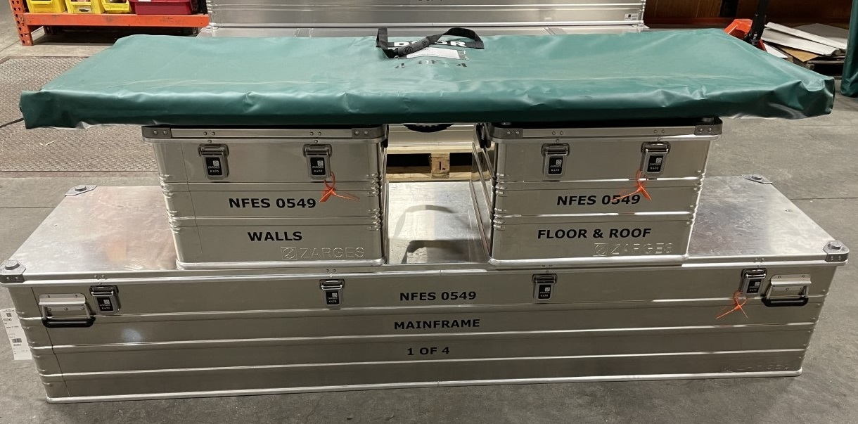
  - 1 Door container (includes a door)

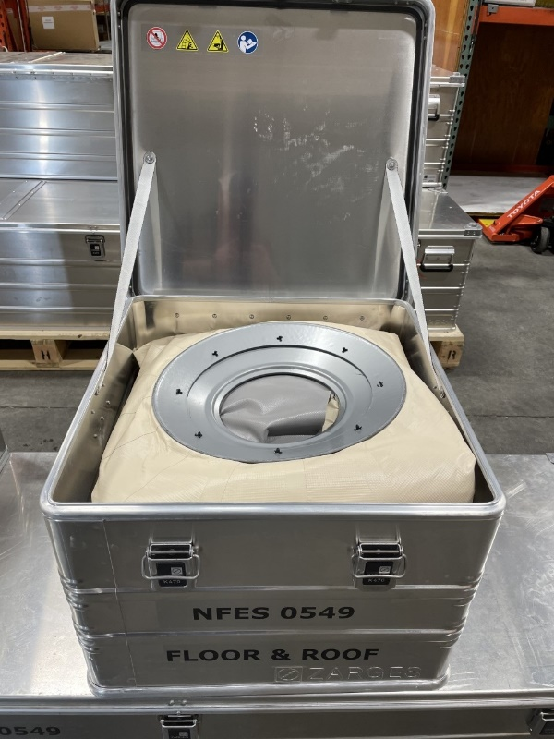
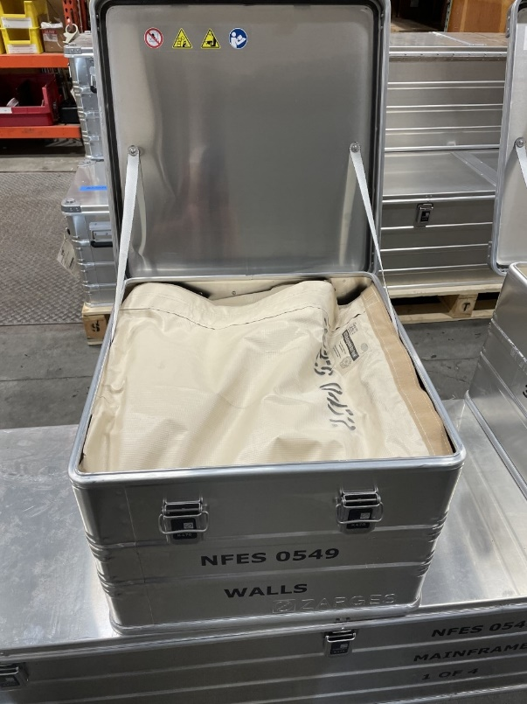
Below are the individual containers open with their components. (Door not shown)
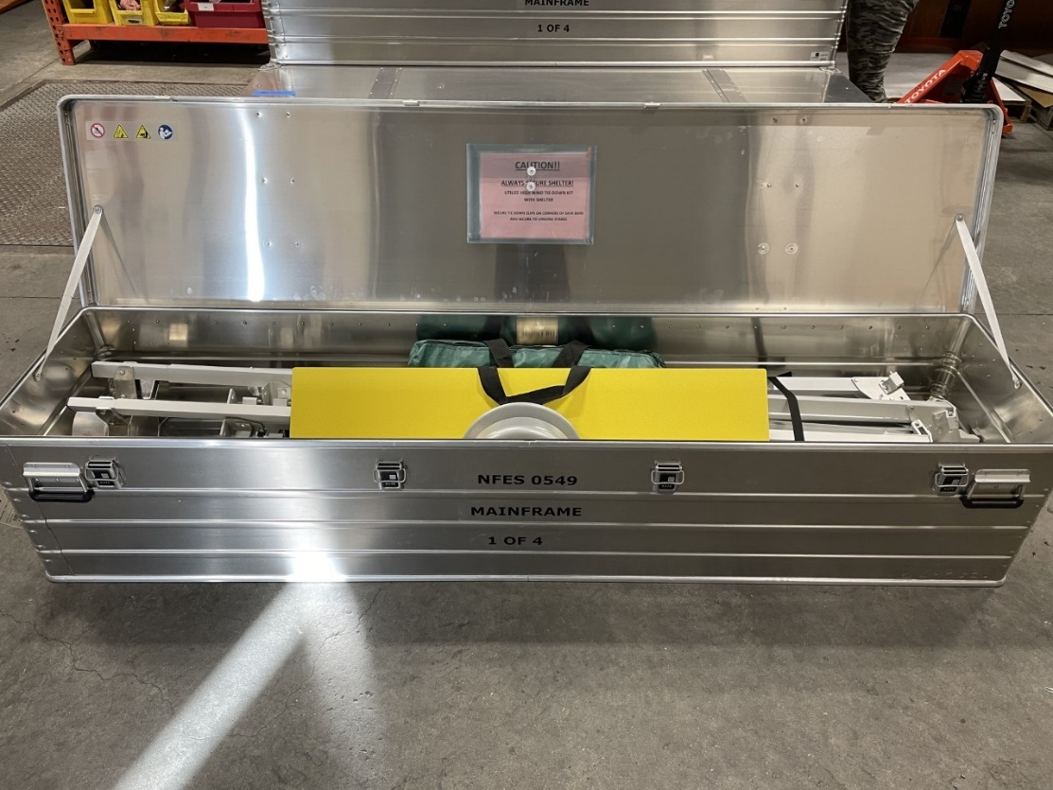
- If a 0581 Insulation kit is ordered along with the 0549 Shelter, it will be shipped in another Zarges container. The Insulation kit is not automatically included and must be specifically requested.
- The 0581 Insulation kit includes a set of reflective walls that will be installed on the inside of the Yurt, underneath the original wall that comes included with the 0549 Shelter. Instructions for how to set up the insulation kit are included in each container.

